**CJ Garber**

26 Jan 2009

Quincy, Massachusetts

Overdose

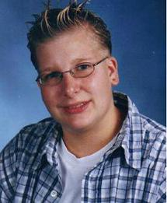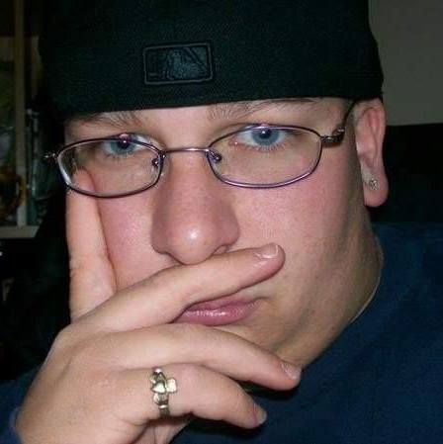

“Tormented by classmates for being transgender, CJ became a heroin user. He was in a rehab program, but on Jan. 26, 2009, he died of an overdose. CJ was 20 years old.”

<https://www.patriotledger.com/article/20090409/news/304099439?template=ampart>

<https://www.boston.com/uncategorized/noprimarytagmatch/2012/10/07/quincy-couple-talk-about-transgender-sons-sad-journey-2>

<https://word.emerson.edu/jsons/2018/03/07/cj-garbers-passing-and-its-relevance-to-anti-discrimination-in-quincy/>

<https://www.youtube.com/watch?v=_po94QU60uI&feature=youtu.be> (Interview with his mother)

<https://www.youtube.com/watch?v=UfG_CbpUSFM&feature=youtu.be> (Interview with his father)

**Lisa Daniels**

17 September 2005

Dorchester, MA

Shot



“Lisa was shot to death on September 17, 2005. She was found dead near a local Stop n Shop. Although she was shot 17 times below the waist, the police refused to consider it a hate crime. Lisa was 42 years old.

(Source: Boston Herald, 9/20/2005)”

**Monique Thomas**

11 September 1998

Dorchester, MA

Globe Articles

“*Dorchester man found murdered*” from Boston Globe (Pg. C11). Sunday, Sep 13, 1998

A man found dead inside his Dorchester apartment building Friday night was murdered, police said yesterday. Rufus Thomas, 35, was found dead about 8 p.m. inside the Park Cinema House apartment complex at 140 Park St., police said. Police believe Thomas may have been the building manager at the apartment building, located near Dorchester Avenue in Fields Corner. Police said they have no suspects in the homicide, but are looking for Thomas's car, which was discovered missing shortly after his body was found. The car is described as a brown 1990 Cadillac Seville, bearing Massachusetts license plate number 379-XZO.

“*Slain man's car is found by police*” from Boston Globe P. B8. Tuesday, Sep 15, 1998

Police have recovered a car owned by a man who was found murdered in Dorchester Friday night, police sources said last night. Rufus Thomas's brown 1990 Cadillac Seville was found yesterday at an undisclosed location, and homicide detectives were dusting the car for fingerprints, the sources said. Thomas was found dead at about 8 p.m. Friday inside the Park Cinema House apartment complex at 140 Park St. near Dorchester Avenue in Fields Corner. His car had been reported missing shortly after his body was found.

“*Suspect arrested, faces extradition*” from Boston Globe (Pg. B5). Wednesday, Sep 23, 1998

MANCHESTER, N.H. -- A Massachusetts man is being returned to his home state for questioning about a killing. George A. Stallings, 25, of Boston waived extradition Monday at a hearing in Manchester District Court. Police say they arrested Stallings Sunday while he was driving a Cadillac stolen from the dead man, Rufus Thomas. He was charged with possession of stolen property and falsely identifying himself as Thomas. Thomas' body was discovered last week in his Boston-area apartment.

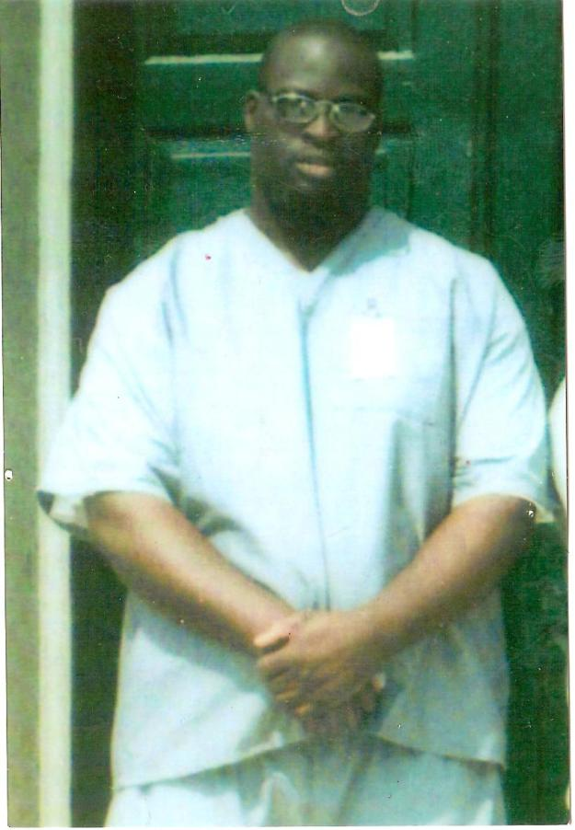 A picture of George Stallings